Computer Science 220

Program 7 – Vigenere

Learning objectives:
Develop a Python program that uses the author's graphics package.
Practice processing string data.
Practice function development.
Practice conditionals.

Assignment Overview:
For this problem you are going to write a program to implement the Vigenere cipher. This is similar to Caesar cipher except a different shift amount is given for every character in the message. The shift amount is based on a provided keyword.

Your program should use a graphical user interface to accept the message to be encoded and the key phrase. Upon clicking in a button “Encode” your program should encode the message and then display the encoded message in a text area. Clicking “Decode” should result in the message being decoded. Shown below is an example of the user interface I want you to design and implement.

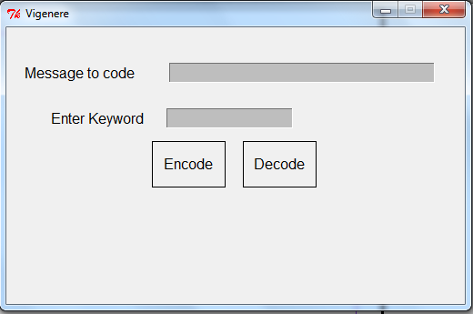

Once the user clicks within the window, the buttons should disappear and be replaced by the appropriate message and the words “Click anywhere to close window.” See the examples of end shots later in this document.

Assignment Specifics:
- Although the original message may have spaces and both uppercase and lowercase letters, you should remove all spaces and change the letters of the message to encode to uppercase. Thus the message “Attack at Dawn” will be changed to “ATTACKATDAWN” before being encrypted. Likewise the Keyword should be changed to all uppercase before using it. You may assume the message only contains spaces and letters and that the keyword contains only letters, although they may be mixed case.

- The computational form of Vigenere encryption requires that the letter “A” be mapped to the value 0, the letter “B” to 1, etc. through mapping the letter “Z” to 25 for both the given message and the keyword. We leave the details of how to do this to you.

- Your code should include a function code(encodeType, message, keyword) that accepts three strings that represent the type of coding, initial message and keyword. The function should return a string that is the encoded message. The type of coding will either be “encode” or “decode”.

- Additional functions should be written as needed to develop a modularized solution.

Sample Ending Shots:
Encode Button Clicked:
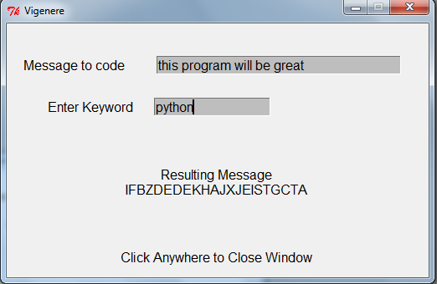

Decode Button Clicked:
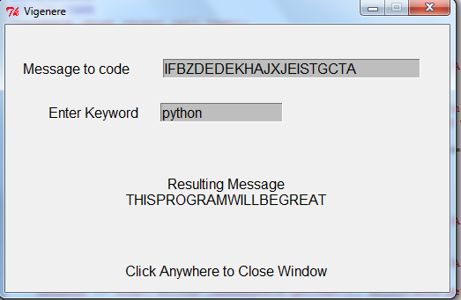

No Button Clicked:
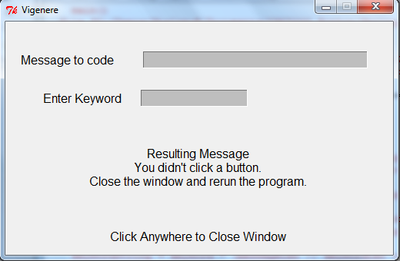

Documentation and Style: You are expected to appropriately document and format your program. This means at minimum inserting header information (file name, your name, program description, certification of authenticity), using meaningful variable names where appropriate, and using a consistent indentation style. You do not have to print an introductory message since this is not typically done in graphics-oriented programs. I also expect to see appropriate comments briefly explaining related code segments and each function.

Submission: Upload vigenere.py to your class Oaks account.

